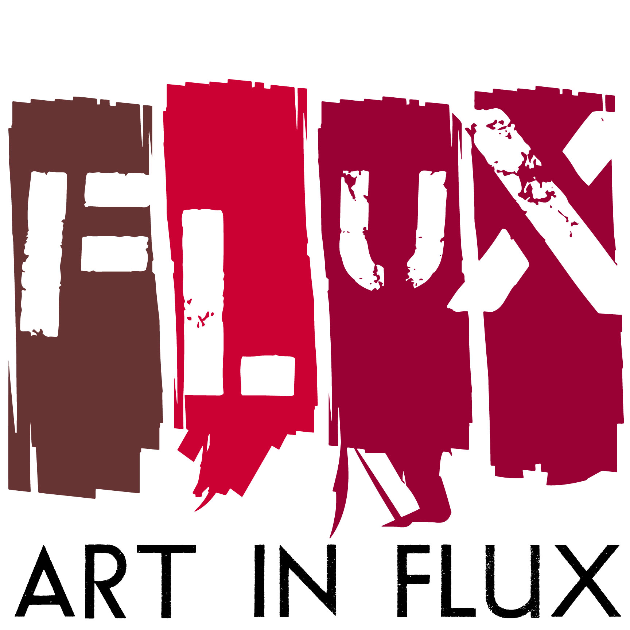

For Immediate Release
Press Contact: Samantha Kessler, samkessler@jccmanhattan.org, 646.505.4493
Leanne Stella, Leanne@artinfluxharlem.com, 917.273.4405

“Allusions”
JCC Harlem launches brand new community space with Art In FLUX exhibition

HARLEM, NY (December 26, 2016) – Art In FLUX presents an exhibition with JCC Harlem opening on 118th Street the first week in January. JCC Harlem invited Art In FLUX to present its opening exhibition because of Art In FLUX’s years of work in Harlem activating spaces with pop-up art galleries and public art installations with a focus on inclusivity, diversity and community engagement. The exhibition opens on Wednesday, January 4, 6:00 to 9:00 PM at JCC Harlem and features eleven artists; Alice Mizrachi, Aya Rodriguez-Izumi, FEEGZ - Carlos Jesus Martinez Dominguez, Jenevieve Reid, Michael Pribich, MOOSH, Noreen Dean Dresser, Suprina, Tammy Nguyen, Uday K. Dhar and Xavier Roux.

“We are so excited to open with Allusions because it highlights the incredible diversity of creative works happening in Harlem,” said Meg Sullivan, Director of Programs & Community Engagement at JCC Harlem. “It has been a pleasure and an honor to partner with Art in Flux in our first months, to help us say hello to the Harlem community.”

The exhibition includes two-dimensional and multi-dimensional (some interactive) installations presented by uptown artists hailing from vastly different backgrounds and upbringings who share a message of multiculturalism and inclusiveness. The works explore immigration, cross-cultural existence, intersectionality, religion, politics, and current world events with an artistic vision to encourage empathy, understanding and tolerance.

Suprina’s twenty foot wall of trash, This Too Shall Pass, intimating a landscape alongside Noreen Dean Dresser’s storm paintings of Hurricane Katrina skies, for example, are austere reminders of the imbalances of our ecosystem and more importantly social systems. This Too Shall Pass is made of layers and layers of that which we cast away. Although devoid of life, the implication is apparent that better care should be taken of the earth and the people upon it. Alice Mizrachi’s two works, Mazal and Our Unborn Daughter Desires Peace, are influenced by her identity as an American Israeli. The works are focused on ideas that empower change and encourage community and unity amongst women. Uday K. Dhar has been engaged in an ongoing process over more than a decade of depicting in visual terms the experience of immigration. His new work Professor E. Explains it all to you -THE THREE R's, the first in a series titled Continental Drift depicts a world that is about the free migration of people, flora, fauna and ideas. Aya Rodriguez-Izumi’s meditation room up a set of spiral stairs and hovering above the other artworks further engages visitors offering a moment of self-reflection and perhaps an opportunity to re-enter the main room with an open mind and a willingness to engage anew. These along with all of the works in the exhibition examine disparate thoughts, challenge our current existence and suggest a world that embraces dissimilarities. The abstract installations and two-dimensional works invite visitors to contemplate and understand them on their own time and terms.

Exhibition Information: Allusions
Featured Artists: Alice Mizrachi, Aya Rodriguez-Izumi, FEEGZ - Carlos Jesus Martinez Dominguez, Jenevieve Reid, Michael Pribich, MOOSH, Noreen Dean Dresser, Suprina, Tammy Nguyen, Uday K. Dhar and Xavier Roux
Sponsors: TOWN Residential and VOSS Water
Opening Reception: Wednesday, January 4, 2017, 6:00-9:00 PM
Location: JCC Harlem, 318 West 118th Street, between Frederick Douglass Blvd and Manhattan Avenue, NY 10026
Transportation: C, 2 and 3 trains or M7 to 116th Street / Crosstown M116 to Frederick Douglass Blvd
Exhibition Dates: January 4 through April 15, 2017
Hours: SUN 9am-5pm, MON 7am-6:30pm, TUES 7am-6:30pm, WEDS 7am-9pm, THURS 7am-9pm, FRI 7am-6pm + Shabbat Programs, SAT Hours Vary
More Information: www.artinfluxharlem.com, 646.340.3479, info@artinfluxharlem.com

Images:
- Mazal, Alice Mizrachi, mixed media on canvas, 2014, 91”x71”
- Dream On Me, Xavier Roux, Oil pigments on canvas, 2014, 72” x 48”
- This Too Shall Pass, Suprina, detritus, 2016, 20’w x 8’h
- Darshai, Michael Pribich, Still image from Sift, video filmed in Badakhshan, Tajikistan fall 2016

If you are interested in interviews or photography, please contact
Samantha Kessler, samkessler@jccmanhattan.org, office: 646.505.4493.

# # #
About Art in FLUX:
Art In FLUX creates opportunities for artists by reclaiming underutilized and unique spaces for art exhibitions and creative collaborations. Since its launch in 2012 as an uptown arts initiative, Art in FLUX has popped up in vacant neighborhood retail spaces, parks, lobbies, and street corners. In 2015 FLUX expanded to include the FLUX Art Fair and Public Art Projects. By merging artistic, commercial, and community interests, FLUX supports greater accessibility to the arts, connects art patrons with uptown artists, and promotes diversity and inclusivity in the arts.

About JCC Harlem
Located at 318 West 118th Street, JCC Harlem is a brand-new community space initiative brought to you by JCC Manhattan, in collaboration with UJA-Federation of New York. In our 6,000-square-foot space, we seek to create a hub of Jewish life for Harlem's growing and vibrant Jewish community, hosting holiday celebrations as well as weekly, monthly, and one-time programming for people of all ages and from all walks of life. There will be an exciting array of programming including morning meditation, yoga and MELT Method, family Shabbat and Friday night dinners, Shabbat afternoon programs, Ulpan and adult education, afterschool programs, community engagement through service learning, 20s + 30s events, co-presented ritual events, and birthday parties.

