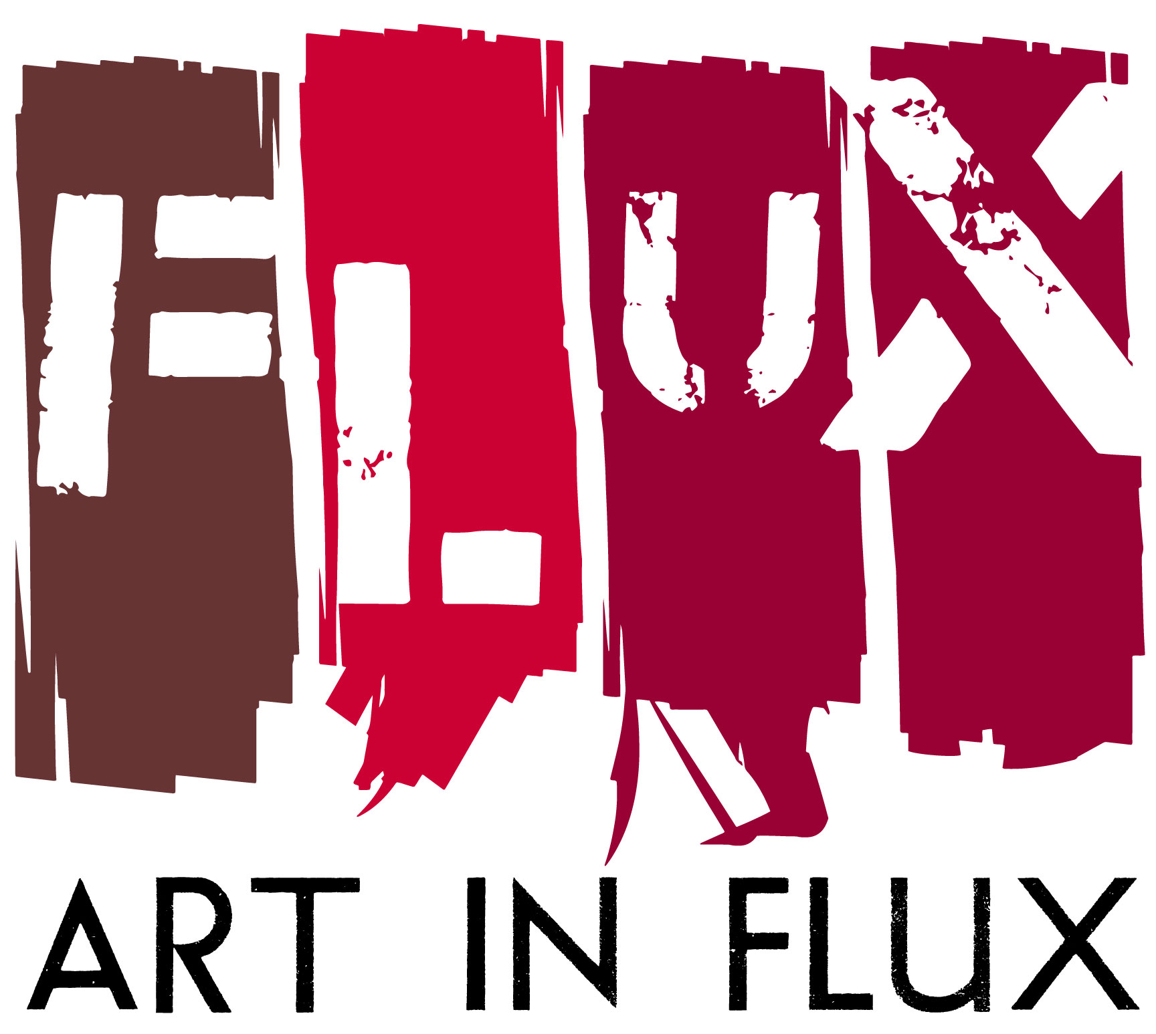

FOR IMMEDIATE RELEASE:

Art In FLUX presents REFRESH at RUSH Gallery
Opening Reception February 23

New York, NY (January 31, 2017) – Art In FLUX brings uptown downtown at RUSH Gallery with an all-women show for the month of March. REFRESH curated by Art In FLUX and hosted by RUSH Gallery opens Thursday, February 23, 6:00-9:00PM at 526 West 26th Street, RM 311, NYC. The women in this exhibition were invited to present ideas within Art In FLUX’s 2017 curatorial theme of Re-Imagining A City, a yearlong curatorial exploration that examines how the structure of cities affects social justice, using art, play, and community engagement as a catalyst for innovating urban life. REFRESH presents a women's perspective and their innate compulsion to create safe, peaceful and equitable spaces. As women they seem inclined to address problems by first reflecting inward … and then projecting outward as a united cohesive force, apparent at the Woman’s March and other recent public forums of solidarity.

Alicia Grullón, Aya Rodriguez-Izumi, Elan, Leslie Jiménez, Rejin Leys, Shani Peters, Sui Park and Suprina each approach the topic in a unique way, some reflecting inward, others directly addressing the current state of affairs, yet all responded in a personal and passionate manner. The artists present a deep emotional connection to their communities and the propensity to internally absorb the trials and tribulations of family, friends, community and world news, thus needing a momentary escape, a REFRESH button, as reflected in Leslie Jimenez’ We've Been Fighting Lately, where an “old” self sits atop a personal bubble… “To be outside and on top of my invisible sacred space…to be present in life… is more than a choice but a responsibility as a woman, mother, and artist.” – Leslie Jimenez. Through their art the artists analyze the disparities, injustices and suffering. They create environments and experiences that challenge the status quo. They listen, comfort, embrace, and absorb the pain. They REFRESH and face the world again.

Exhibition: REFRESH
Artists: Alicia Grullón, Aya Rodriguez-Izumi, Elan, Leslie Jiménez,
Rejin Leys, Shani Peters, Sui Park and Suprina
Opening: February 23, 6:00-9:00PM
Dates: February 23 to March 24,2017
Location: RUSH Gallery, 526 West 26th Street, RM 311
Hours: Wednesday to Saturday 12:00PM-6:00PM
Info: www.artinfluxharlem.com www.rushphilanthropic.org

Image:
- What’s for dinner, Suprina, mixed media, 2017, 34” x 22” x 18”
- Water, Leslie Jimenez, Stitched drawing, 2017, 6.5” x 8.5”

# # # # #

About Art in FLUX:
Art In FLUX creates opportunities for artists by reclaiming underutilized and unique spaces for art exhibitions and creative collaborations. Since its launch in 2012 as an uptown arts initiative, Art in FLUX has popped up in vacant neighborhood retail spaces, parks, lobbies, and street corners. In 2015 FLUX expanded to include the FLUX Art Fair and Public Art Projects. By merging artistic, commercial, and community interests, FLUX supports greater accessibility to the arts, connects art patrons with uptown artists, and promotes diversity and inclusivity in the arts.

About RUSH Gallery:
Rush Arts Gallery supports the diverse creative practices of the emerging artistic community, including artists, curators and writers from around the globe. Rush Arts Gallery provides an inclusive space for new audiences and promotes experimental ventures in visual art, curatorial visions, performance art, and community involvement.

About the Artists:
Alicia Grullón
Alicia Grullón is an interdisciplinary artist whose vision is to use art to create a world that does not yet exist. Whether through socially engaged projects, performance, works on paper, video or photography, she takes into account the use of space as a site of social construction where issues of race, class, gender, and activism open. Her involvement comes from wanting to re-write history interrupting traditional dialogues in order to show a perspective closer to that lived by people. She immerses herself drawing from intersectional feminist and critical race theories in her campaign to decolonize the world through art. What her role is as an artist in the community are questions she has been exploring in past socially engaged work and performance art pieces. She sees that art like politics questions how we establish our presence in the world. Grullón has spoken at the United States Society on Art in Education, Association of Art Historians in London and the Queens Museum for the Open Engagement Conference, May 2014. She completed residency programs with the Bronx Museum of the Arts, Arts Council Korea, and Volunteer Lawyers for the Arts and in Germany. Grullón has presented at El Museo del Barrio, Performa 11, Bronx Museum of the Arts, and Art in Odd Places. Her work has been funded by the Puffin Foundation, Bronx Council on the Arts, the Department of Cultural Affairs of the City of New York, and Franklin Furnace Archives. Most recently, she has conducted workshops for 350NYC.org and Naturally Occurring Cultural Districts in New York.

Aya Rodriguez-Izumi
Aya Rodriguez-Izumi is an artist living and working in Harlem whose practice includes sculpture, music, installation and performance. Her work deals with how communication informs enculturation and molds the understanding of the self. She approaches this theme often in a satirical manner and calls on personal experiences of grappling with her own cultural identity. She has spent her life moving back and forth between New York City and her birthplace of Okinawa, Japan. Being half Cuban/Puerto Rican and Okinawan/Japanese, socio-cultural identity has always been a focus of her work and life. Since graduating from Parsons the New School for Design she has been included in various group shows and has shown at such venues as MoCADA, The Knockdown Center, Free Candy and FLUX Art Fair among others. She is currently an MFA candidate at SVA.

Elan
As an Access Assemblage interdisciplinary visual artist and writer Elan’s works are grounded in family, historical imagery, personal narrative, memory and identity. She is interested in power dynamics that exist in families, how individuals form identity under these influences and how that is interjected into society and popular culture. Elan studied Advertisement, Design and Photography at FIT and graduated from City College of New York City with a BA in Studio Art and Education, 2008. She has instructed young people in the arts for 16 years at the Brooklyn Museum and many upper Manhattan institutions such as Say Yes To Education (affiliated with Columbia’s Teachers College), Harlem School of the Arts, Thurgood Marshall Upper and Lower Academies, Harlem Gems (Harlem Children Zone), No Longer Empty, Cool Culture, Bank Street College, the Studio Museum in Harlem, New York Historical Society, Center for Arts Education. She is currently an MFA candidate at SVA.

Leslie Jiménez
Leslie Jiménez is a Dominican multidisciplinary artist and illustrator based in NY where she works and lives with her husband, daughter and two blood parrot fish. Ms. Jiménez graduated from the prestigious Altos de Chavón School of Design, in the Dominican Republic. She was awarded a full scholarship and graduated with honors from Parsons The New School for Design in New York City. Leslie's work has been exhibited in galleries in NYC, Washington DC, Barbados, Santo Domingo, SCOPE Contemporary Art Fair NY, and New York Presbyterian - The Allen Hospital. Other venues include PBS, and online magazine Mashable. Jiménez has been invited to talk about her work at El Museo del Barrio, CNN en Español, Rutgers University, City College, Art In FLUX and Parsons The New School.

Rejin Leys
Rejin Leys is a mixed media artist and community papermaker based in New York, whose drawings and artist’s books have been exhibited at such venues as Centro Culturel de Espana, Santo Domingo; Kentler International Drawing Space, NY; Queens Museum, NY; and Les Ateliers J.R. Jerome, PaP, Haiti. Her work is in the collections of the Schomburg Center for Research in Black Culture, Yale University, and Rutgers University Caribbean Studies Department, and she is a recipient of a fellowship from the New York Foundation for the Arts.

Shani Peters
Shani Peters (b. 1981 Lansing, MI) is a multi-disciplinary artist based in New York City. Her practice encompasses community building, activism histories, the subversion of popular media, and the creation of accessible imaginative experiences. Peters holds a B.A. from Michigan State University and an M.F.A. from the City College of New York. Her exhibitions and presentations in the United States and abroad include the Schomburg Center for Research in Black Culture in New York City; the University of Michigan, Ann Arbor, MI; Seoul Art Space Geumcheon in South Korea; and the National Gallery of Zimbabwe in Harare. Selected residencies include those hosted Lower Manhattan Cultural Council, Museum of Contemporary Art Detroit, the Laundromat Project, and Project Row Houses, as well as a residency in Seoul, South Korea sponsored by apexart. Peters’ work has been featured in the Art Papers magazine and the New York Times. Her work is recognized and supported by several awards and grants from institutions such as the Foundation for Contemporary Arts, the Rauschenberg Foundation, Rema Hort Mann Foundation, and the Joan Mitchell Foundation. Peters is an educator, focusing her teaching at the intersection of art and politics.

Sui Park
Sui Park is a New York based artist and an interior architect born in Seoul, Korea. Her work involves creating 3-dimensional flexible organic forms of a comfortable ambiance that are yet dynamic and possibly mystical or illusionary. She recently had a solo exhibition ‘Playing with Perception’ at the Denise Bibro Fine Gallery in Chelsea, New York in April 2016. She also had a solo exhibition ‘Garden of Humans’ at Kingsborough Community College, CUNY, Brooklyn, NY in March 2016. She participated over 50 exhibitions, including a two-person exhibition, Uncommon Landscapes, Art FLUX Harlem, New York, July 2016. Sui Park is also a Bronze Awardee in ‘2013-2014 A’ Design Award’ in Arts, Crafts and Ready-Made Design Category with her design ‘SuiTable’. Sui Park’s education includes MDes in Interior Architecture at Rhode Island School of Design in 2013 and BFA in Environmental Design at Maryland Institute College of Art in 2011. Sui Park also has MFA and BFA in Fiber Art at Ewha Womans University, Seoul, Korea.

Suprina
Suprina’s finesse with found objects comes from her work as a sculptor and prop maker for clients such as Annie Leibovitz, Apple, Bloomingdales, Fortunoff and the Macy’s Thanksgiving Day Parade. Her artworks deal with the human condition and social issues and incorporate detritus, castings, modeling, and painting. She has created a number of public art projects including the DNA Totem featured in the FLUX Art Fair 2016, now on view at the Rye Arts Center, Rye, NY through spring 2017. Other public art commissions and awards include Figment NYC 2012, ‘Best Portfolio’ by Pro Arts 2013 and 2015 and grants by the Puffin Foundation and Lower Manhattan Cultural Council. Suprina made a splash in 2013 when thirty-two of her sculptures installed in the Morristown courthouse were deemed dangerous to the public by the County Sheriff, who placed a 24/7 guard on the work and ordered them removed. The experience inspired Suprina to create a series of ‘Dangerous Art’ and another series related to the theme of ‘Injustice in the Justice System’.

