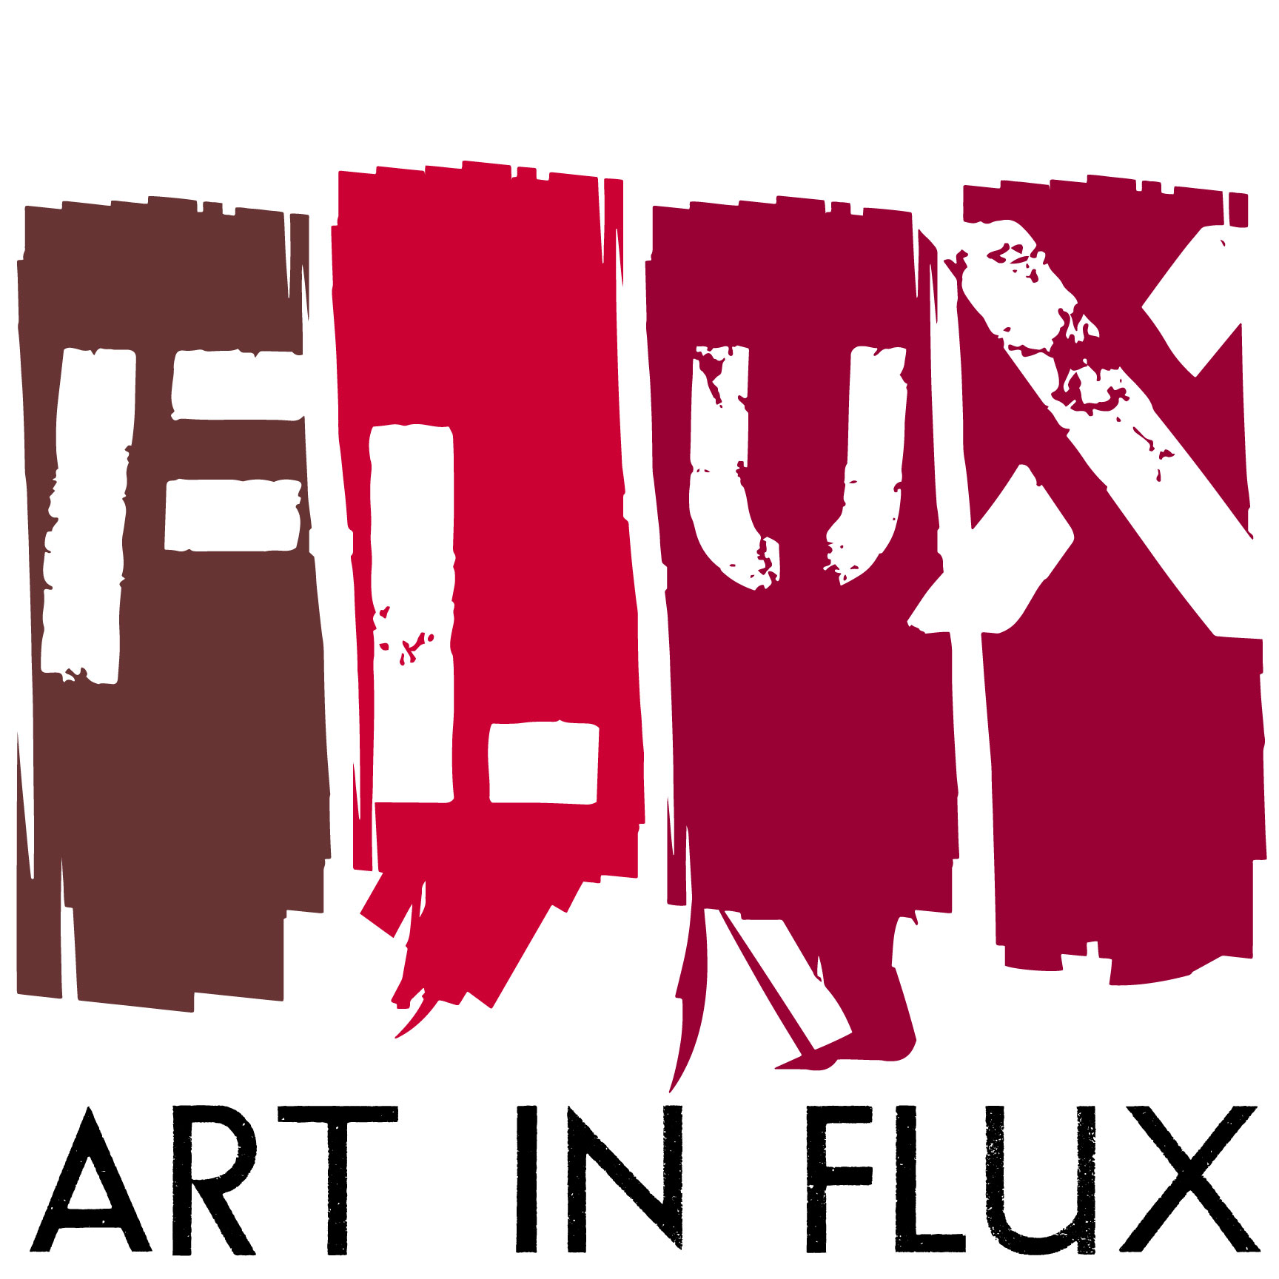

FOR IMMEDIATE RELEASE:

“FOUR FLIGHTS UP”
Bohemia Realty Group opens new condo on November 15 with an Art In FLUX exhibition

HARLEM, NY (October 31, 2016) – When Bohemia Realty Group called on Art In FLUX to launch a pop-up exhibition at their newest luxury condo conversion, The Leo at 427 West 154th Street, Leanne Stella, Director of Art In FLUX quickly started calling her artist connections in the neighborhood, climbing flights of stairs to visit studios, and handpicked a small group of artists that would tell a story about Sugar Hill and Harlem. Art In FLUX, an uptown arts initiative, started out presenting pop-up art shows in empty storefronts and has grown to include an art fair, public art installations and advocating for artists. “It’s important for artists and the arts to be considered as the neighborhood evolves” comments Stella. “Meeting artists is a great way for newcomers to gain an appreciation for the rich history, the flavor, and the sense of community that exists in Sugar Hill and across Harlem.”

Bohemia Realty Group, the preeminent brokerage for sales, commercial, and residential leasing in Upper Manhattan and the Bronx, is extending its role as a neighborhood advocate and real estate promoter by showcasing four local artists at The Leo, a Neo-Renaissance, prewar condominium at 427 West 154th Street in the exclusive Sugar Hill section of Harlem. Listed by Beth Gittleman, Head of Sales for Bohemia and senior sales agent Susan Molloy, the idea to join forces with Art in FLUX was a no brainer. “Our company has a mission to support the arts in our local community,” points out Gittleman. “With this exhibition, we are thrilled to bring together and highlight our beautiful new condo conversion with four amazing Harlem-based artists.”

Just as John P. Leo, the original developer and architect of The Leo building, made his mark on Upper Manhattan designing residential developments out of his Harlem office in the early 1900’s, artist Leslie Jiménez works in her studio just two blocks away and four flights up. The windows are sometimes shaded to help her resist lingering on the distractions outside that often end up in her creations. Jiménez works in watercolor, pencil and thread. Her most recent series are depictions of architectural elements from the very same neighborhood viewed from the perch of her window-side artist stool and drafting table. While she weaves black thread through fine paper, Jiménez remembers and honors the brick and mortar of the century old buildings and the artisans that came before her; connecting the stories of the past with today’s Sugar Hill.

Five blocks in another direction and four flights up is the studio of Leon Johnson. Like Bohemia’s co-owner Sarah Saltzberg (Broadway actor, writer and producer), Johnson arrived in New York as an actor and singer. On a fluke, he ended up working at the famed Red Rooster Harlem where, by happenstance, Marcus Samuelsson discovered Johnson is also an artist and asked him to create images for the Red Rooster Cookbook that launched in October this year. Four Flights Up includes original illustrations from the book along with larger works by Johnson. His artwork is persuaded by the little interruptions of daily life. An apple rolls across the counter or a mouse scatters across the subway tracks and suddenly a series of mini sketches becomes a sequence of related and unrelated stories. The little story boxes he sketches become one big colorful arrangement of previously unrelated things, much like strangers coexist on the sidewalk or in the A train, eventually becoming one beautiful intermingled arrangement of diversity... such is also the nature of Harlem.

Moving around the corner … four flights up… is the studio of Gregory Saint Amand aka GOGO. Like Johnson and Jimenez, Saint Amand is also inspired by the fluidity and beauty of the neighborhood. His work is heavily influenced by his younger years in Haiti but the layers in his mixed media paintings have as much to do with his childhood as they do his morning cup of coffee, the conversation at the bus stop or the flower pushing through the sidewalk cracks. Many of us remember the games of hide and seek at dusk with the kids on the block. Saint Amand’s “Hide and Seek” mixed media piece harkens back to Haiti and yet resonates whether one were raised on 154th Street, Port-au-Prince or the North Fork. His paintings are abstractions of every day life layered with history and memories that crisscross street corners and oceans alike. Saint Amand discovers details as he paints, layering images, hinting at philosophies, nodding to contemporary culture and then leaves the work to us to uncover, to peel back layer by layer, and rediscover that which was hidden.

Although he doesn’t live in Sugar Hill at the moment, Lance Johnson is a second-generation Harlem artist. His grandfather tended parks in the neighborhood while his mom played on the swings nearby. Lance’s artwork is permanently installed in various locations throughout Harlem including two restaurants and a cycling gym affirming him as one of the artists of the current Renaissance. His graffiti / street style work layers old world Harlem often including quotes or concepts from writers like Langston Hughes and Ralph Ellison who haunt the brownstones of Sugar Hill. His newest functional works will reveal his affection for the historic enclave that many people are just rediscovering.

Four Flights Up shares the intimacies of the neighborhood by looking into and looking out of the artist’s window. Harlem is a culturally rich and diverse community of which artists have always played a significant role. It is equally important to remember the artists and writers of the Harlem Renaissance as it is to acknowledge, patronize and understand the artists of today. Embrace the artist and you will be embraced by a warm and welcoming, uniquely diverse and evolving community. A percentage of all art sales in Four Flights Up will be donated to Creative Art Works, a visual and multimedia arts organization that provides dynamic arts experiences for youth who otherwise lack access. Supporting CAW through this exhibition contributes to the encouragement and empowerment of the next generation of artists in this community.

Exhibition Information: “Four Flights Up”
Featured Artists: Leslie Jiménez, Lance Johnson, Leon Johnson, Gregory Saint Amand
Opening Reception: November 15, 6:00-9:00PM
November 15 – December 27, 2016
Open by appointment 646-340-3479 or info@artinfluxharlem.com and during special open house events: www.bohemiarealtygroup

Location:
The Leo, 427 West 154th Street, main floor

For more information:
www.artinfluxharlem.com
info@artinfluxharlem.com
646-340-3479
Images:
- Hide and Seek, Gregory Saint Amand, 2015, Mixed media, 48'x48'
- Morning Walk by The Bell, Leslie Jiménez, 2016, Stitched drawing, 9" x 9"
- Brought to You By the Letter A, Leon Johnson, 2016, Mixed media, 31”x36”
- Invisible Man, Lance Johnson, 2016, Acrylic on canvas, 40”x30”

ABOUT THE ARTISTS
Leslie Jiménez is a Dominican multidisciplinary artist and illustrator based in NY where she works and lives with her husband, daughter and two blood parrotfish. Ms. Jiménez graduated from the prestigious Altos de Chavón School of Design, in the Dominican Republic. She was awarded a full scholarship and graduated with honors from Parsons The New School for Design in New York City. Leslie's work has been exhibited in galleries in NYC, Washington DC, Barbados, Santo Domingo, SCOPE Contemporary Art Fair NY, and New York Presbyterian - The Allen Hospital. Other venues include PBS, and online magazine Mashable. Jiménez has been invited to talk about her work at El Museo del Barrio, CNN en Español, Rutgers University, City College, Art In FLUX and Parsons The New School.

Leon Johnson is an illustrator and ﬁne artist, born and raised in Kansas City. He was interested in drawing from a very early age and was heavily inﬂuenced by caricature artists Jack Davis and Al Hirschfeld. He holds a Bachelor of Fine Arts from the Kansas City Art Institute. His ﬁrst professional job was for the newspaper Pitch Weekly in Kansas City, MO. Leon works primarily in mixed media, ink, paint, and found objects. He is attracted to texture and various mediums and searches for many ways to create images, often revisiting drawings and paintings done in the past, believing there’s always something different to be said. Johnson’s work can currently be seen in The Red Rooster Cookbook by Chef Marcus Samuelsson (October 2016) and at The Red Rooster restaurant.

Gregory Saint Amand aka GOGO was born in New York, but raised in Haiti from age one to his early teens when he returned to the US to live again with his mother. He works in multiple mediums, including inks, acrylics, charcoal, pen and markers, painting on canvas, wood and even cardboard. His work juxtaposes figurative and abstract imagery, infusing meaning through complex layering with a diverse assortment of cultural icons. Gregory earned his B.A. at Cooper Union. His has exhibited in the African American Museum, PA (2016); the Makeshift Museum, LA (2016); and Scope Miami Art Fair (2015) with Castle Fitzjohns Gallery. His artwork is in numerous private and corporate collections including the Red Alder Hedge Fund. ArtVoices named him one of the 101 top contemporary artists for 2016.

Lance Johnson was raised in the Bronx with deep family ties in Harlem. He is a self-taught mixed media artist, inspired heavily by Romare Bearden and drawing influence from hip-hop culture and the energy of NYC. He is a graduate of City College where he studied journalism. Lance is also known for his murals and also paints murals with teen groups where he guides them through topics such as diversity, cyber bullying, and the false ideals of beauty. His work has been exhibited at Art In FLUX, Harlem Eat Up, Harlem Arts Festival and Hudson Valley Center for Contemporary Art. He was recently selected for the 2017 Harlem 125th Street BID banner project. His commission work includes Zipcar, Angel Restaurant (Harlem); Corner Social (Harlem); City MD (Harlem); Harlem Cycle; 5th & Mad; Harlem 125; and Macondo East (LES).

ABOUT BOHEMIA REALTY GROUP:
Bohemia Realty Group is the premier sales, commercial, and residential leasing brokerage in Upper Manhattan and the Bronx. The boutique firm currently has a team of more than 120 licensed agents and brokers, almost all of who reside above 110th Street. Founded in 2012, Bohemia Realty Group has offices located at 2101 Frederick Douglass Blvd. in Harlem and 3880 Broadway in Washington Heights.

ABOUT ART IN FLUX:
Art In FLUX creates opportunities for artists by reclaiming underutilized and unique spaces for art exhibitions and creative collaborations. Since its launch in 2012 as an uptown arts initiative, Art in FLUX has popped up in vacant neighborhood retail spaces, parks, lobbies, and street corners. In 2015 FLUX expanded to include the FLUX Art Fair and Public Art Projects. By merging artistic, commercial, and community interests, FLUX supports greater accessibility to the arts, connects patrons with uptown artists, and promotes diversity and inclusivity in the arts.

ABOUT CREATIVE ART WORKS ("CAW")
Creative Art Works is a 30-year-old creative youth development nonprofit that improves the lives of thousands of young people each year through the power of art. Our visual and multimedia arts programs include in-school and out-of-school-time classes, community art-making events, and our renowned public art youth employment program. Working in NYC, with a focus on Upper Manhattan, in public schools, community and cultural centers, parks, and libraries, CAW provides dynamic arts experiences for youth who otherwise lack access. Our programs build confidence, unlock a love of learning, and teach valuable technical, developmental, life and job skills, all while creating profound connections between our young constituents, their art, and their communities.

# # # # #

