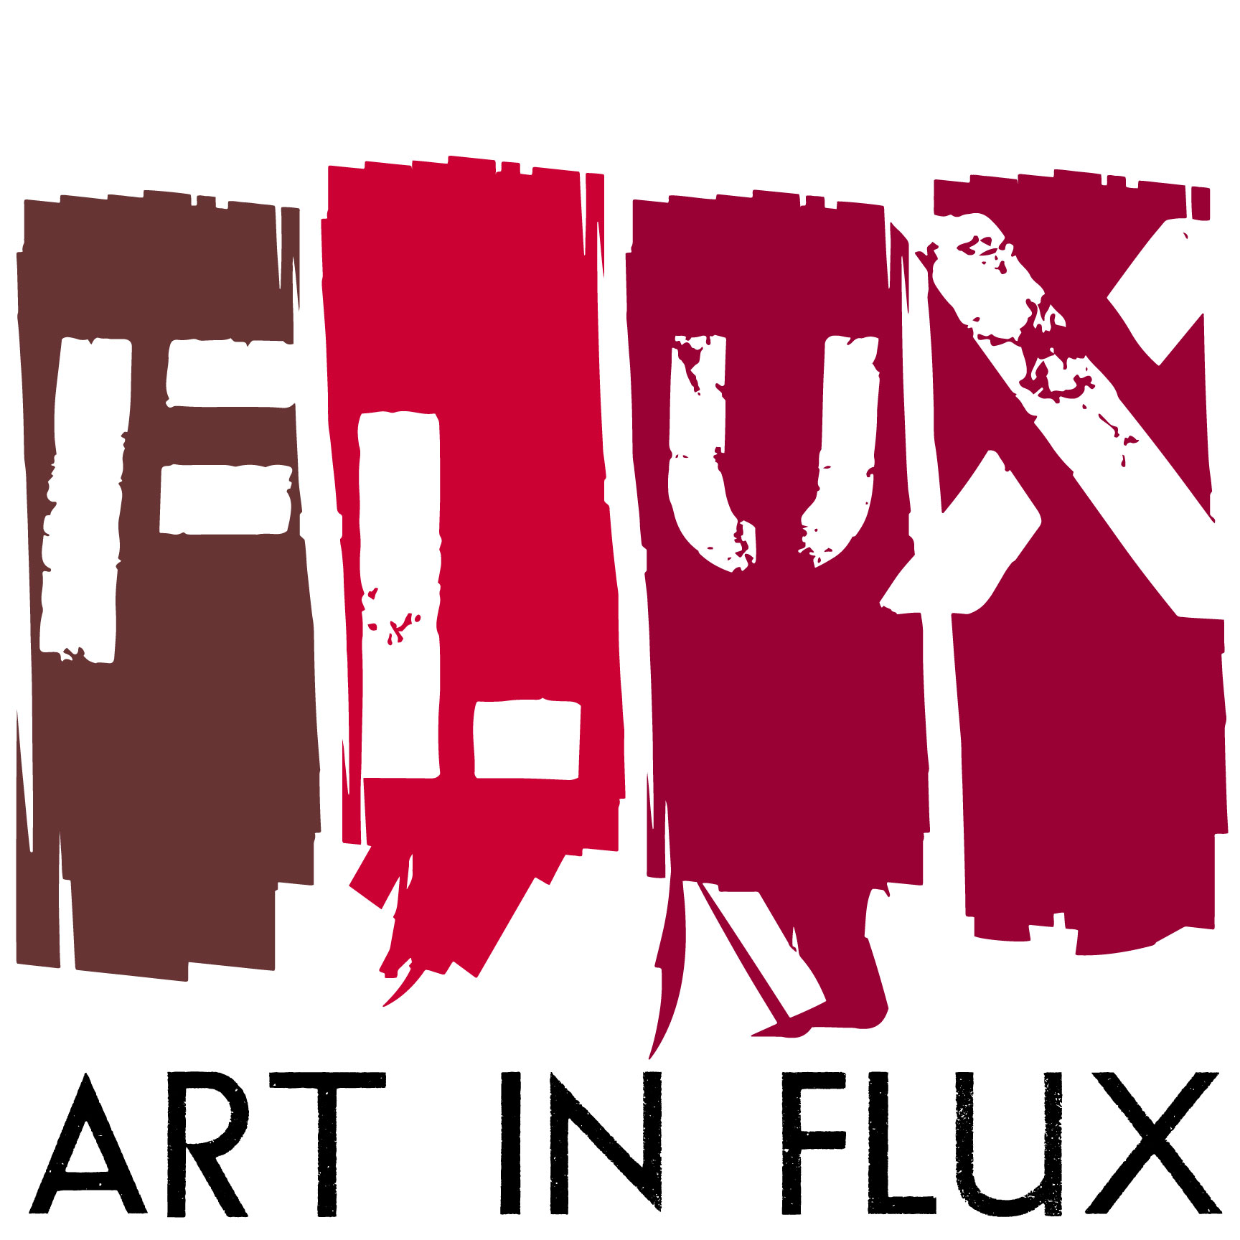

FOR IMMEDIATE RELEASE:
“I AM A GOD”
A new series “Mythomania” by Uday K. Dhar opens on November 16
HARLEM, NY (October 24, 2016) – “I Am A God” exhibition featuring a new series, Mythomania by Uday K. Dhar opens on Wednesday, November 16 from 5:00-9:30PM at the Art In FLUX storefront gallery hosted by Harlem Properties located at 163 Malcolm X Blvd. between 118 and 119th Streets, NYC.
Dhar’s works are as much an exploration of materials and textures as they are an examination of historical context and an introspective search. Upon first view it’s the choice of materials that entices a closer look at Dhar’s artworks. Each piece speaks to you “come close, step back, turn the lights on, turn them off, repeat, repeat, repeat”. And each time another nuance is uncovered. The materials and how Dhar uses them play a significant role in the development of each piece in this series.
Greek and Roman mythology has set the standard by which we judge beauty and for what is considered desirable, standards that have been absorbed and accepted unconditionally for centuries. Throughout the Mythomania series, Dhar recreates the Gods in a series of mixed media studies with a new lens and in a contemporary context. He cultivates an alternative view of the history of Western Art by questioning what this imagery means to a person of color. With each application of paint and various other materials a conversation is happening between Uday Dhar and the deity. What makes the works intriguing is the subtle sensation that Dhar lived inside each one of them as he went through the process… becoming a reinvented version of Adonis, Apollo, Hercules, Sebastian and so on.
Uday K. Dhar immigrated to the United States from India as a teenager in the early 70's. His artistic process explores the transformation that occurs as a result of dislocation and migration to a foreign country. He is constantly challenging that which may be deemed “normal” in a particular place and time. Through his paintings and mixed media works he pushes himself to reverse techniques or resist his formal training. For example in his rendition of Adonis, the light colored shading that you would expect to be the last color applied and the closest to you is actually the original color of the found boards he used as the canvas and thence the light colors are the furthest in the background. This process of challenging techniques is a parallel discovery process to Uday’s persistent interrogation of what is “normal”. Within the studio Uday is always posing two ways of thinking about painting, two ways of approaching a technique. These dualities and dichotomies are a constant reflection of how he feels as an immigrant balancing ideas from the East in a modern Western culture.
Uday K. Dhar was trained as an architect, earning his B.A. at Columbia College, Columbia University, and an M.A. at the Graduate School of Architecture and Planning, Columbia University. He is a former fellow of Vermont Studio Center, the MacDowell Colony and Yaddo. In the early 90’s while living in Berlin he gave up architecture to devote himself to making art on a full time basis. His work is a commentary on his experience immigrating to the United States from India as a teenager in the early 70's. Dhar’s works are held in numerous private collections and have been exhibited globally including The African American Museum, PA (2016), FLUX Art Fair, NY (2015), Whittier Center in Boston, MA (2014), The Schomburg Center for Research in Black Culture, NY (2014), Leroy Neiman Gallery, NY (2013), Gallery Art and Soul, Mumbai, India, (2013), Figment, Governor’s Island, NY (2012) and Queens Museum, NY (2011).

Exhibition Information: “I Am A God” the Mythomania series
Featured Artist: Uday K. Dhar
Opening Reception: November 16, 5:00-9:30PM*
November 16 – January 2017
Open Monday to Friday 10:00AM-5:00PM, Saturday Noon-3:00PM and by appointment 646-340-3479 or info@artinfluxharlem.com

* NOTE extended hours for the opening reception of "I Am A God" so that guests can visit before or after the member's preview of The Studio Museum in Harlem's Fall/Winter 2016–17 Exhibitions and Projects.
Location:
Art In FLUX, 163 Malcolm X Blvd. between 118th and 119th Streets, Harlem, NY

For more information:
www.artinfluxharlem.com
info@artinfluxharlem.com
646-340-3479
Images:
- Apollo, 2016, Oil, crayon, enamel and shellac on tar paper mounted on wood panel, 48”x36”
- Adonis, 2016, Oil, wax, and spray paint with oil print transfer on wood panel, 48”x36”

About Art in FLUX:
Art In FLUX creates opportunities for artists by reclaiming underutilized and unique spaces for art exhibitions and creative collaborations. Since its launch in 2012 as an uptown arts initiative, Art in FLUX has popped up in vacant neighborhood retail spaces, parks, lobbies, and street corners. In 2015 FLUX expanded to include the FLUX Art Fair and Public Art Projects. By merging artistic, commercial, and community interests, FLUX supports greater accessibility to the arts, connects art patrons with uptown artists, and promotes diversity and inclusivity in the arts.
The 163 Malcolm X Blvd gallery space is sponsored by Harlem Properties.
About Harlem Properties:
Harlem Properties is a boutique real estate brokerage led by President John McGuinness, a Harlem resident with an affinity for the architectural history of the neighborhood. The firm’s first storefront location opened in 2016 at 163 Malcolm X Blvd features an art gallery curated by Art In FLUX. Harlem Properties specializing in investment sales, residential sales, and commercial leasing in Harlem as well as property acquisitions throughout greater New York City.

# # # # #

