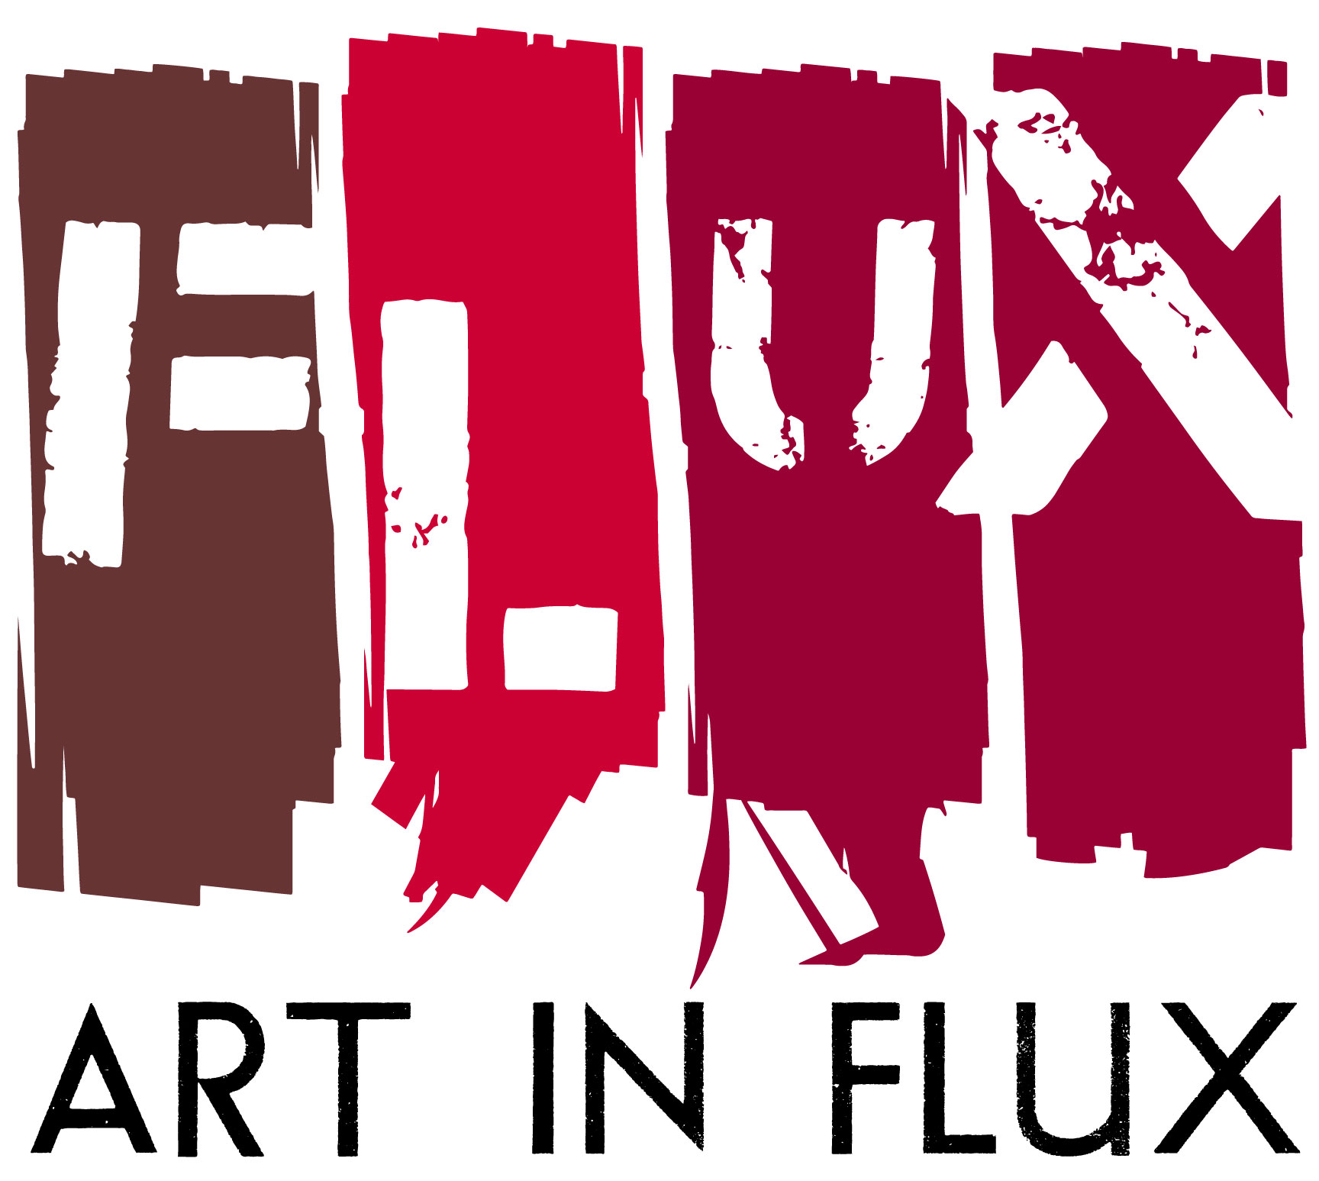
FOR IMMEDIATE RELEASE:

Art In FLUX presents FEEGZ Selects,
a collaboration with Carlos Jesus Martinez Dominguez
Opening Reception February 8
HARLEM, NY (January 31, 2017) – Art In FLUX collaborates with artist, curator, educator and community activist Carlos Jesus Martinez Dominguez on an upcoming exhibition, FEEGZ Selects: Lineas, Formas, Colores y Cuadriculas (FEEGZ Selects: Lines, shapes, color and grids) featuring Dominguez’ (aka FEEGZ) selection of five uptown Caribbean American artists. FEEGZ Selects opens Wednesday, February 8, 6:00-9:00PM at the Art In FLUX storefront gallery hosted by Harlem Properties located at 163 Malcolm X Blvd. between 118 and 119th Streets, NYC.

The artists – Coco144, Glendalys Medina, Manuel Acevedo, Pepe Coronado and Rejin Leys – cross generations and artistic backgrounds but share commonalities in their Caribbean heritage, New York City roots, artistic lens, and examination of current events. Their works uniquely interpret the most basic elements of art – lines, shapes, and colors – resulting in geometric designs that activate the senses and awaken ideas. Though made up of these simple artistic constants, the complex works powerfully convey sociopolitical issues from identity and borders, to space and history. Their resultant simplicity and abstraction present viewers with an opportunity to explore new ideas and perspectives on current events.

Exhibition: FEEGZ Selects: Lineas, Formas, Colores y Cuadriculas
Curated by: Carlos Jesus Martinez Dominguez
Artists: Coco144, Glendalys Medina, Manuel Acevedo, Pepe Coronado, Rejin Leys
Opening: February 8, 6:00-9:00PM
Dates: February 8 to March 31,2017
Location: Art In FLUX, 163 Malcolm X Blvd, NY
Hours: Monday to Friday 11:00AM-5:00PM, Saturday Noon-3:00PM
and by appointment 646-340-3479 or info@artinfluxharlem.com
Info: www.artinfluxharlem.com
info@artinfluxharlem.com
646-340-3479
Image:
- "F" (Architectonic Alphabet in RBW), Manuel Acevedo 2012, Variable Dimensions
- Additional images available on request

# # # # #
About Art in FLUX:
Art In FLUX creates opportunities for artists by reclaiming underutilized and unique spaces for art exhibitions and creative collaborations. Since its launch in 2012 as an uptown arts initiative, Art in FLUX has popped up in vacant neighborhood retail spaces, parks, lobbies, and street corners. In 2015 FLUX expanded to include the FLUX Art Fair and Public Art Projects. By merging artistic, commercial, and community interests, FLUX supports greater accessibility to the arts, connects art patrons with uptown artists, and promotes diversity and inclusivity in the arts.

The 163 Malcolm X Blvd gallery space is sponsored by Harlem Properties.

About Harlem Properties:
Harlem Properties is a boutique real estate brokerage led by President John McGuinness, a Harlem resident with an affinity for the architectural history of the neighborhood. The firm’s first storefront location opened in 2016 at 163 Malcolm X Blvd features an art gallery curated by Art In FLUX. Harlem Properties specializing in investment sales, residential sales, and commercial leasing in Harlem as well as property acquisitions throughout greater New York City.

Curator: Carlos Jesus Martinez Dominguez
Caribbean New Yorker, Atheist on some days, Non Theist Agnostic on others, Liberal, Socialist, Advocate, Agitator, Ethical Polyamorist, Marijuana Enthusiast, HS dropout, GED holder, Autodidact, Educator, Debater, white people fearing, All people loving, LGBYQ allying, Hip Hop, Sneaker, Comic and Sci-fi passionate Dominican Puerto Rican Interdisciplinary Artist born on a military base in North Carolina in 1976. Carlos Jesus Martinez Dominguez a.k.a FEEGZ, Figaro & Firo173 has exhibited taught and spoken in dozens of institutions nationally and internationally, really. NYC since 84, (www.feegz.wordpress.com)

About the Artists:
Coco144
COCO 144 (Roberto Gualtieri) began to write his name on the streets of Upper Manhattan in 1969. He is considered one of the first renowned pioneers of the graffiti culture and movement. While painting in the subway system, he introduced the use of a stencil, making him the first writer to innovate this technique of writing your name with rapidity on a wall or a train surface. As a result, the writing community considered him “all city”, a term that signified his name was everywhere. In 1973, Coco also transitioned writing and graffiti culture with his graffiti writing collective, UGA (United Graffiti Artists), bringing writing above ground from the trains into the gallery scene in downtown Manhattan. His work was featured at the Razor Gallery, a groundbreaking show that shifted the public’s perception of graffiti and ushered in a new era for an art form that what would soon become a global cultural phenomenon. His commission and exhibition work is extensive and includes a mural commission of Sensory Exploration, Rockefeller University’s Neuroscience Laboratory, 2008 and 2014; the Cartier Foundation’s Born in the Streets exhibit, Paris, 2009; a 56 painting installation titled “Scientifically Correct” at Bard College’s Reem Kayden Gallery in Annandale-on-Hudson, New York, 2010; The Art in the Streets exhibit, MOCA, Los Angeles, 2011; the (S) Files Bienal in El Museo del Barrio, NY, 2011; and Luciano Benneton’s "Imago Mundi” exhibition at the Querini Stampalia Foundation, Venice, 2013.

Glendalys Medina
Born in Puerto Rico and raised in the Bronx, Glendalys Medina is an interdisciplinary artist receiving her MFA from Hunter College in 2008. Medina’s work has been exhibited at such notable venues as Artists Space, Bronx Museum and El Museo del Barrio. She was awarded a SIP fellowship at EFA Robert Blackburn Printmaking Workshop in 2016, a BACK IN FIVE MINUTES artist residency at El Museo Del Barrio in 2015, a residency at Yaddo in 2014, the Rome Prize in Visual Arts in 2013 from the American Academy in Rome, a NYFA Fellowship in Interdisciplinary Art in 2012, and the Bronx Museum's Artist in the Marketplace residency in 2010.

Manuel Acevedo
Manuel Acevedo's work combines projected image, wall drawing, animation, and photography to explore how light and movement shape experience. Through various media he employs visual language in ways that transform flat, static images into active spaces of experimentation. Acevedo has been exhibiting his work in the United States and abroad for over twenty-five years. Recent exhibitions include Translated Cities, at the Shirin Gallery in NY, Playing with Fire at El Museo del Barrio in NY and Our America: The Latino Presence in American Art (traveling exhibition) curated by E. Carmen Ramos at the Smithsonian American Art Museum in Washington D.C. He has had solo exhibitions at the Bronx River Art Center, Latino Cultural Center in Dallas, TX, and Jersey City Museum. Among his awards and residencies are those received from the Joan Mitchell Foundation, Visual Artist Network, Longwood Arts Project, Mid-Atlantic Foundation, Museum of Art & Design (Artist Studios), and Studio Museum in Harlem, AIR. Acevedo is currently developing multiple journals, book projects that include photo-based images, text-based (typographic) visuals and architectonic models for large-scale interactive spaces. He conceptualizes and processes ideas all the time - in conjunction with raising a family in the Bronx, teaching, making site-specific installations and participating in residencies. His work is built on thirty years of practice inspired by the richness and complexity of urban experiences and city lore.

Pepe Coronado
Coronado is a master printer with experience at Pyramid Atlantic in Silver Spring, Maryland; the Hand Print Workshop International in Alexandria, Virginia; and the Serie Print Project in Austin, Texas. Coronado taught printmaking at the Corcoran College of Art, Georgetown University, and at the Maryland Institute College of Art in Baltimore where he earned the Master of Fine Arts. He is currently a resident teaching artist at the Hudson River Museum, NY. Coronado’s most recent solo exhibitions include Projects Photo / Prints, Gallery 410 GooDBudY, Washington, DC; Construcciones-Obstrucciones 2005-2010 at Casa de Teatro Santo Domingo D.R. for the PhotoImagen Biennial; the Center for the Digital Arts, Westchester Community College, New York; Obstrucciones, Gallery 101, Georgetown University, Washington DC; and Amos Eno Gallery, Brooklyn, NY. His group exhibitions include Superreal at El Museo del Barrio, El Panal/The Hive, Trienal Poli-Grafica de San Juan Puerto Rico curated by Deborah Collins; 6th international Printmaking biennial of Douro, Portugal curated by Nuno Canela; and Directions: DC Contemporary Latino Art, Frida Kahlo Gallery, Cultural Institute of Mexico, Washington, DC curated by Laura Roulet. Coronado’s work is in many collections including CUNY Dominican studies Institute, City College of New York City, El Museo el Barrio, the Rutgers Archives for Printmaking Studios, Georgetown University, Lauinger Memorial Library of Rare Books and Prints Collection, the Library of Congress, the Eugene and Agnes E. Meyer Foundation, the Federal Reserve Board of Governors Art Collection, District of Columbia Government: Arts and Humanities Commission, El Paso Museum of Art and Mexic-Arte Museum.

Rejin Leys
Rejin Leys is a mixed media artist and community papermaker based in New York, whose drawings and artist’s books have been exhibited at such venues as Centro Culturel de Espana, Santo Domingo; Kentler International Drawing Space, NY; Queens Museum, NY; and Les Ateliers J.R. Jerome, PaP, Haiti. Her work is in the collections of the Schomburg Center for Research in Black Culture, Yale University, and Rutgers University Caribbean Studies Department, and she is a recipient of a fellowship from the New York Foundation for the Arts.

