FOR IMMEDIATE RELEASE:
Contact: Leanne Stella www.artinfluxharlem.com
917-273-4405 Leanne@artinfluxharlem.com

Art In FLUX Pops Up at Aloft Hotel, Harlem
HARLEM, NYC - November 20, 2013 - Art In FLUX Harlem and Aloft Hotel launch a collaboration to promote visual artists in Harlem. On the evening of December 3, 2013 Art In FLUX presents two Harlem artists, Andre Woolery and Ruben Natal-San Miguel, in the lobby of Aloft on their dedicated art walls. Aloft has a company-wide commitment to support the local artistic community by devoting space to presenting art. Art In FLUX hopes to utilize the Aloft Harlem space to present unique and compelling exhibits that create conversation and highlight the dynamic contemporary art culture in Harlem.
This inaugural exhibit at Aloft is titled NOTHING IS COLORPROOF after a piece by Andre Woolery of the same name. “Nothing is Colorproof” is a triptych of a gun shooting a swirling rainbow of colors. “A gun represents both chaos and order. In the chaos of my thoughts and ideas, color is the organizing order. It brings clarity to a vision. If my mind were the weapon and my ideas were the bullets... then color would be the force propelling it forward” states Andre.
Both Andre and Ruben reflect on culture, race, and gender through their own mediums - paint & pushpins and photography, respectively. They each capture moments in time and exploit the use of color and light to convey a sense of hope. Ruben chronicles Harlem by photographing the people and the architecture that are the fabric of the community. Andre paints iconic images hoping to open our eyes to a new set of possibilities. Together these two artists open a window on our society and awaken our consciousness.

Much of the work in this exhibit evokes a tangle of ideas or emotions. You might look at the photograph titled “Stop & Frisk” by Ruben and decide it’s a statement against the policy, but view the photo without the title and you see a young boy holding a basketball given to him by the NYPD. New York City is full of these dichotomies – things that are celebrated and lamented at the same time. Ruben photographs gentrification yet admits to being part of the gentrification himself. As a 12-year veteran of Harlem he is neither a newcomer nor an old-timer. Andre’s pushpin and oil on canvas piece of Radio Raheem highlights his signature Love Hate rings. In Spike Lee’s film “Do The Right Thing” Radio Raheem tells the story of Right Hand, Left Hand. “It’s a tale of good and evil. Hate: it was with this hand that Cane iced his brother. Love: these five fingers, they go straight to the soul of man.…One hand is always fighting the other hand..”
-more -

NOTHING IS COLORPROOF opens on December 3rd at 6:30pm.
WHAT: NOTHING IS COLORPROOF, pop-up art exhibit and sale
WHO: Featured Artists: Andre Woolery and Ruben Natal-San Miguel
WHEN: December 3, 2013 through January 31, 2014, Open Daily
WHERE: Aloft Harlem Hotel, 2296 Frederick Douglass Blvd. at 124th St, Harlem, NYC
INFO: www.artinfluxharlem.com

OPENING RECEPTION: December 3, 6:30 to 9:30pm sponsored by 5&Diamond Harlem and Papi Wines
RSVP: 646-340-3479 or info@artinfluxharlem.com
PHOTOS ATTACHED
1. “Nothing Is Colorproof” Andre Woolery, triptych 18”x24” oil on canvas
2. “Stop & Frisk” Ruben Natal-San Miguel, 20”x24” limited edition photograph
3. “Love/Hate” Andre Woolery, 36”x60” pushpins and oil on canvas

ABOUT

Art In FLUX Harlem is a movement of artists appearing in Pop-Up art galleries featuring special events and creative collaborations with theatre, film, music, and fashion industries. FLUX highlights and creates opportunity for artists living and/or working in Harlem, brings art into public spaces, creates a positive use for vacant retail locations and other underutilized spaces, stimulating a vibrant neighborhood merging art, commerce and community

Aloft Harlem is a boutique hotel located in Manhattan’s hottest cultural destination known for beautiful brownstones, legendary soul food and historic religious institutions.
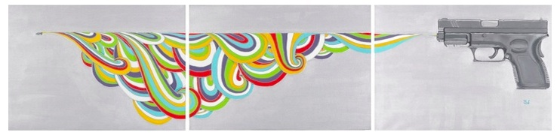
1.

#####

\
2.
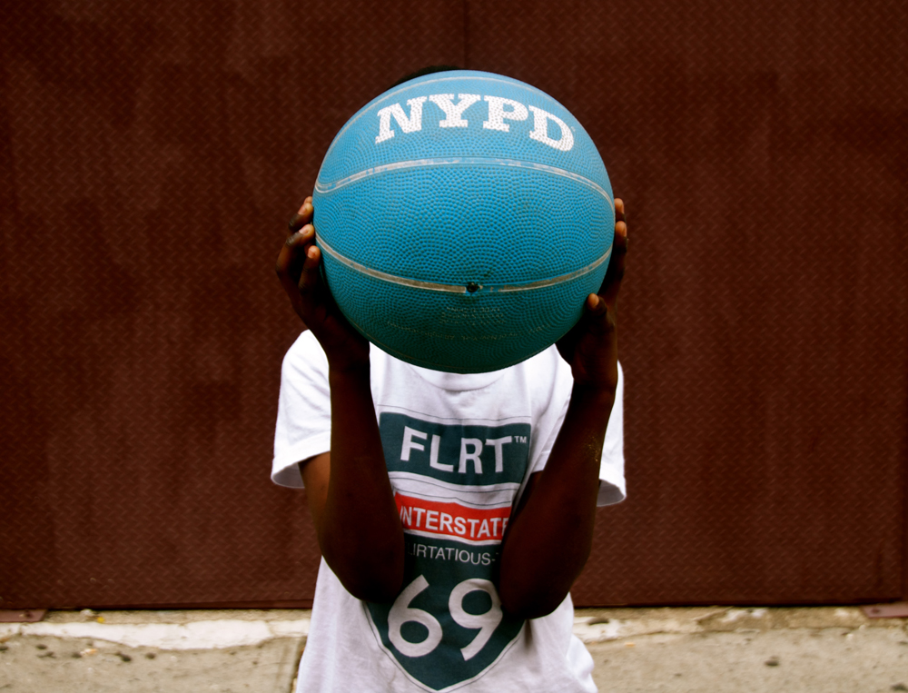

3.
